COMP 2152 – Assignment 01

Dear Team,

I hope you are doing GREAT!

The assignment has two parts. The coding part has 5% value, and the YouTube presentation has 5%.

The assignment is easy to follow yet needs the patience to solve each question at a time.

**Note:**

In short, 5 for coding + 5 for the video presentation = 10. **However, if you do not submit a link to a YouTube video, you will receive 0% for you Assignment mark.**

***Important:***

* This is an individual assignment (complete the requirements on your own).
* Do not share the assignment requirements with any former or future students in COMP 2152. Do not share this assignment requirements online in any format, anywhere.
* You may choose to complete all requirements or attempt to complete as much as possible.
* Credit will be awarded for requirements completed correctly and entirely with the portion of the program functioning as requested. No partial marks will be awarded.
* You are allowed to make assumptions about application functionality not mentioned in the project idea (which is more of a general guideline).
* At a minimum your project must display the functionality described for the idea selected. Any functionality described that is not a part of your submission will result in grade penalties at the discretion of the instructor.

***Submission:***

* Submit Python files only. No other format is accepted.
* DO NOT submit zipped (compressed) files. Any compressed files will not be marked.
* Please make sure that as a comment you will type on top of your code the name of your Lab Professor.

e.g. **#Lab Professor: Michael** OR **#Lab Professor: Reza**

* Submit on Blackboard.

Please develop a Python application that meets the requirements described below:

***Project Description:***

**Scenario:**

Write a program for a retail store that will allow them to calculate discounts for their employees when they buy items.

Discounts are based on the number of years worked (2% for each year, maximum 10%) as well as if the employee is a manager (10% more discount on top of the worked year discount) or hourly employee (2% discount). They are also allowed no discount once they have received $200 discount.

The program starts asking for the employee discount number to start purchasing. The employee can purchase 1 item at a time. Do this until the user answers “NO” for “Another purchase?”. Once all employees have been processed, display the All-Employee Summary and give the users option to go back to Menu or Exit the program.

A workflow diagram is provided for each function to help students visualize the flow through the program.

**Actions:**

1. Menu Pages:

Create the menus below using a square created in the console by printing dashes (-) and pipes (|) where appropriate. It should look something like this but large enough to cover almost ½ of your computer screen when printed on the console (no need to calculate for the monitor size-just approximate is fine):

————

| |

————

e.g.

———————————————

| 1- Create Employee |

| 2- Create Item |

| 3- Make Purchase |

| 4-All Employee Summary |

| 5-Exit |

———————————————

1. Specific Menu Pages to Create:

**2.1. Create Employee Page**

a. Please define a function that asks the user to get the employees’ information and add that to the list. Whenever the user enters “NO” it will finish getting the employees’ information.

b. Use a 2-dimensional list to create and save the employee information where each item in the list consists of the information of 1 employee:

[Employee ID, Employee Name, Employee Type, Years Worked, Total Purchased, Total Discounts, Employee Discount Number]

E.g.

employee_list = [

[1001, John Alber, hourly, 8, 0, 0, 22737],

[1002, Sarah Rose, manager, 12, 0, 0, 22344],

[1003, Alex Folen, manager, 5, 0, 0, 22957],

[1004, Pola Sahari, hourly, 17, 0, 0, 22488]

]

c. Inputs must be validated to satisfy the following requirements:

* Employee ID is unique within the list
* Employee Discount is unique within the list
* Null/empty value is not allowed for any of the fields
* Input must be number for Employee ID, Years Worked, and Employee Discount Number
* Input must be “hourly” or “manager” for Employee Type
* Input is not required for Total Purchased and Total Discounts when the employee is first created in the system, these fields should be assigned with a default value of 0.

Below is the workflow diagram for the Create Employee Process, the check for null values is not included to simplify the diagram. Please make sure to implement all the checks as per requirements.

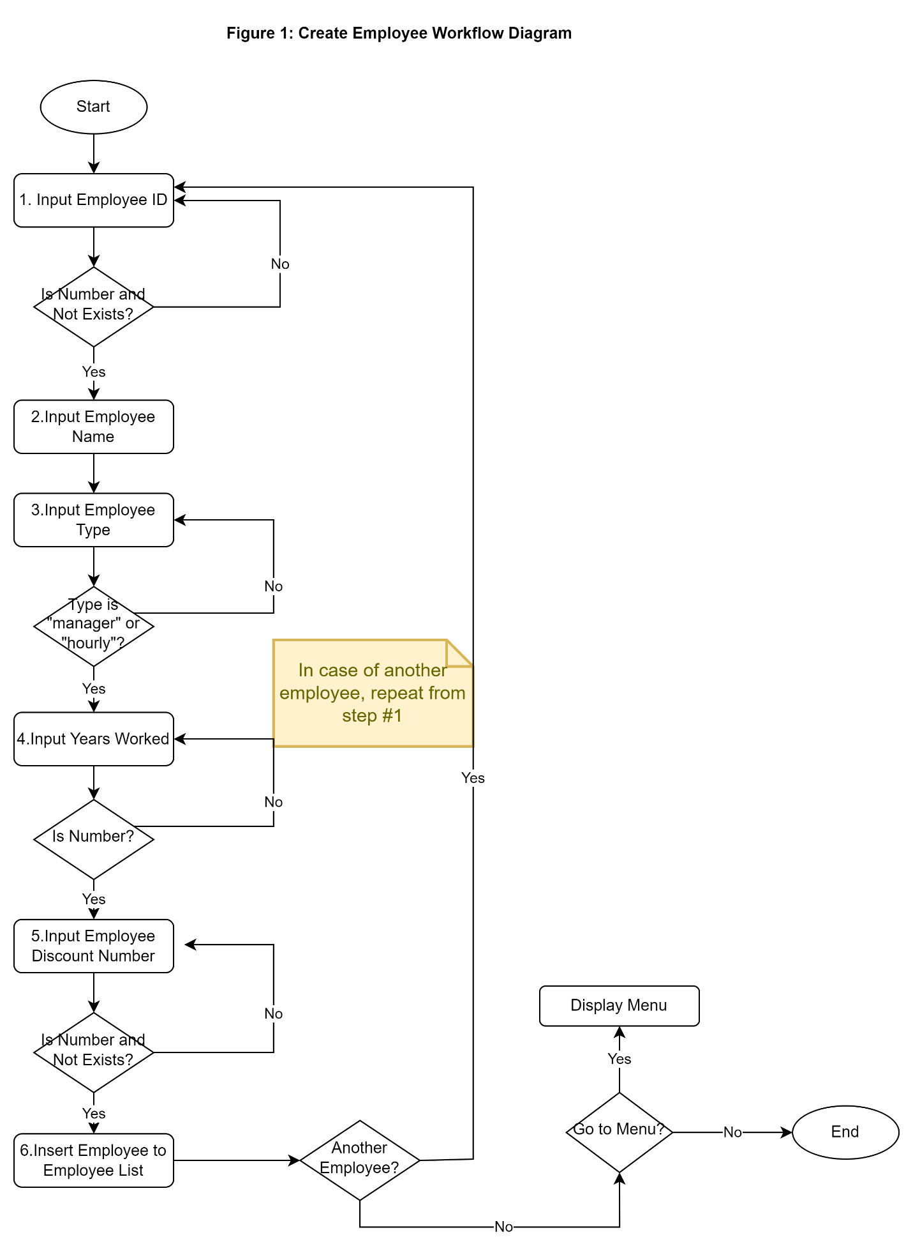

**2.2. Create Item Page**

a. Please define a function that asks the user to get the items’ information and add that to the list. Whenever the user enters “NO” it will finish getting the items’ information.

b. Use a 2-dimensional list to create and save the item information where each item in the list consists of similar information as follows:

[Item Number, Item Name, Item Cost]

E.g.

item_list = [

[11526, Nike shoes, 120],

[11849, Trampoline,180],

[11966, Mercury Bicycle, 150],

[11334, Necklace Set, 80]

]

c. Inputs must be validated to satisfy the following requirements:

* Item Number is unique within the list
* Null/empty value is not allowed for any of the fields
* Input must be number for Item Number and Item Cost

Below is the workflow diagram for the Create Item Process, the check for null values is not included to simplify the diagram. Please make sure to implement all the checks as per requirements.

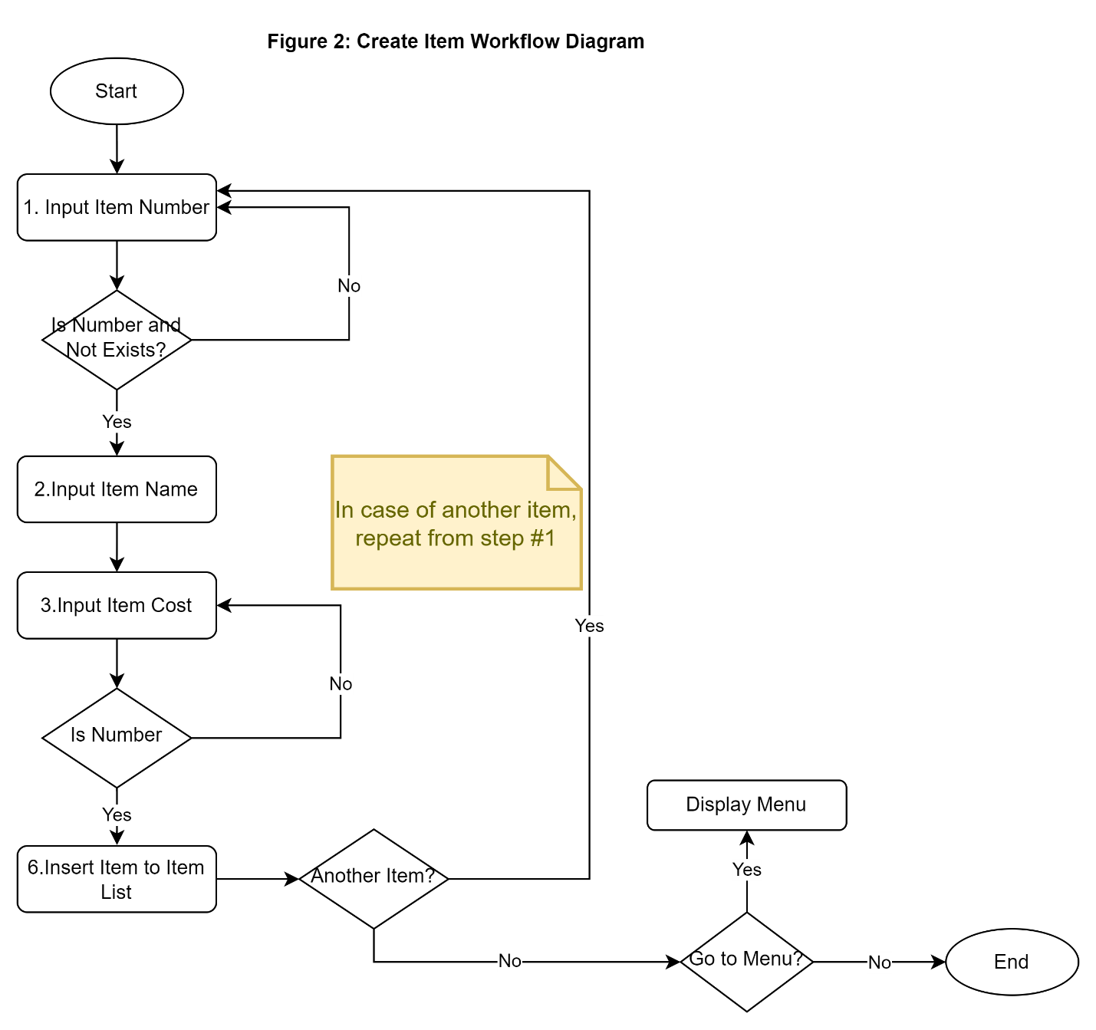

**2.3 Make a Purchase Page**

This page will list all the items available for sales. For each item, display *Item Number, Item Name, Item Cost*. Please choose one of the following formats to display the Item list.

Option 1: Print with format

Item Number | Item Name | Item Cost

11526 | Nike shoes | $120.00

11849 | Trampoline | $180.00

11966 | Mercury Bicycle | $150.00

11334 | Necklace Set | $80.00

Option 2: Simple print

Item Number, Item Name, Item Cost

11526, Nike shoes, $120.00

11849, Trampoline, $180.00

11966, Mercury Bicycle, $150.00

11334, Necklace Set, $80.00

The page then prompts for user inputs such as item number and employee discount number to make the purchase. Do this until the user answers “NO” for “Another purchase?”. Once all employees have been processed, display the All-Employee Summary Page and give the users option to go back to Menu or Exit the program. Following the flowchart diagram below for the purchasing process.

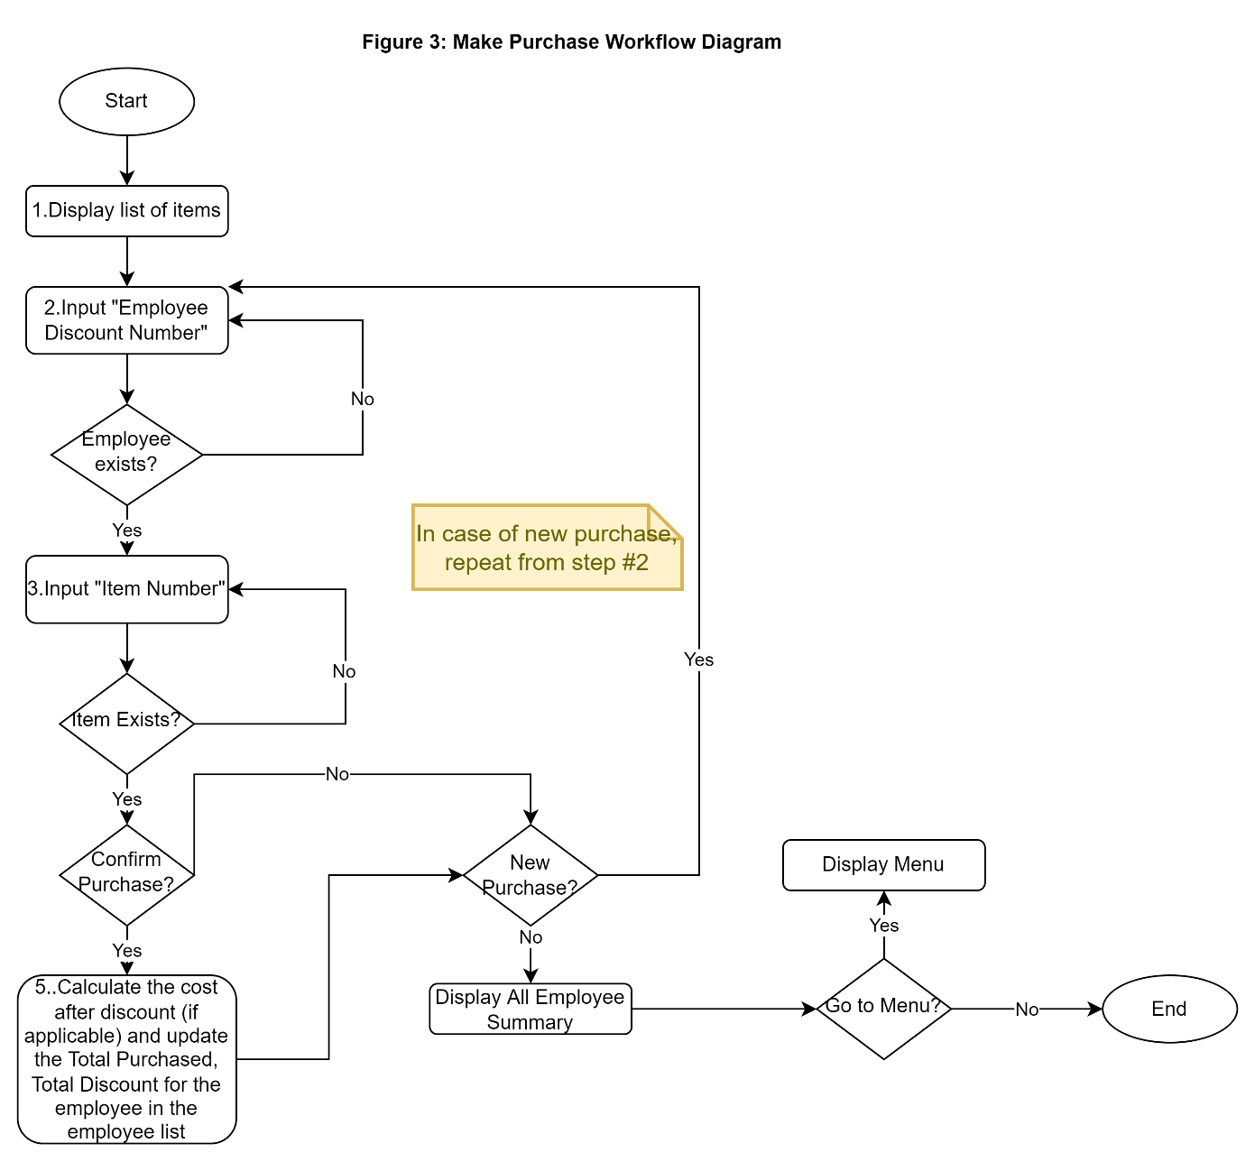

Discounts are based on the number of years worked (2% for each year, maximum 10%) as well as if the employee is a manager (10% more discount on top of the worked year discount) or hourly employee (2% discount). They are also allowed no discount once they have received $200 discount.

**2.4. All Employee Summary Page**

This page will list all the employees of the company. For each employee, display *Employee ID, Employee Name, Employee Type, Years Worked, Total Purchased, Employee Discount Number.* Please choose one of the following formats to display the Employee list.

Option 1: Print with format

Employee ID | Employee Name | Employee Type | Years Worked | Total Purchased | Total Discount | Employee Discount Number

1001 | John Alber | hourly | 8 |$ 90.00 | $10 | 22737

1002 | Sarah Rose | manager | 12 |$ 40.00 | $10 | 22344

Option 2: Simple print

Employee ID, Employee Name, Employee Type, Years Worked, Total Purchased, Total Discounts, Employee Discount Number

1001, John Alber, hourly, 8, 90, 10, 22737

1002, Sarah Rose, manager, 12,40, 10, 22344

This page displays the All-Employee Summary Page and gives the users option to go back to Menu or Exit the program. Following the flowchart diagram below for the process.

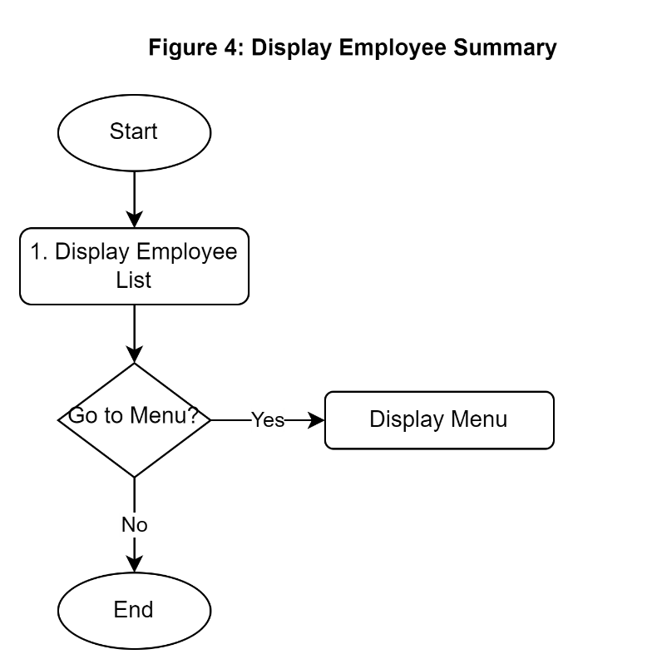

# Deliverables:

1. Please, submit the current ipynb or .py file with your responses.

2. Please record and upload to YouTube a 5 to 10 minutes video recorded clip, describing all you have done. If you go beyond 10 minutes, it is fine. The mentioned time range is to show how the scale of the assignment could be.

Then submit the link to the uploaded YouTube video in the **\*\*Text Submision section\*\*** (see image below).

Notes:

- In your submission, YOU MUST SUBMIT A LINK TO YOUR YOUTUBE VIDEO as a TEXT SUBMISSION SECTION on your BLACKBOARD SUBMISSION. Omitting this BB comment will result in a 0% for your total mark

- To get the 5% of the (coding) mark, you need to at least submit a YouTube video that scrolls through your code at the very least.

- To get the reset of the 5% of the (video) mark, you need to have explanations in your video, and YouTube video that meets all of the requirements listed in the Assignment 2 Instructions.

**\*\*Summary:\*\***

In short, what we need to submit are:

a)  The current **\*\*ipynb/py file\*\*** that contains all the code (5 marks).

b)  The **\*\*YouTube link\*\*** of your recorded video in the **\*\*Text Submission section\*\*** (5 marks).

Wish you only the best, Dear Team Members!

Reza